New Features

Junhyuck Kim jk808

**Mars Lander**

New scenarios including an aero-stationary orbit and 2001 Mars Odyssey orbit

Auto landing using parachute allowing safe landing after orbital re-entry in all scenarios including automatically coming down from an orbit by backfiring

Supports manual attitude control rotating the craft in the plane of the orbit

Supports auto orbital injection into a circular orbit of desired altitude

Supports auto orbital injection into an elliptical orbit of desired apogee and perigee from setting window

Able to deal with moderate levels of engine lag and delay

The mechanics, calculation of ground speed and initial velocities of scenarios take account of rotation of Mars

Simulates steady atmospheric wind flow with randomized wind speed and direction

Simulates additional random gusts that lasts 3~20 seconds

Wind direction takes account of a simple model of wind pattern in Mars

Because of rotation of Mars, easterly winds are featured near the equator1

New User Interface

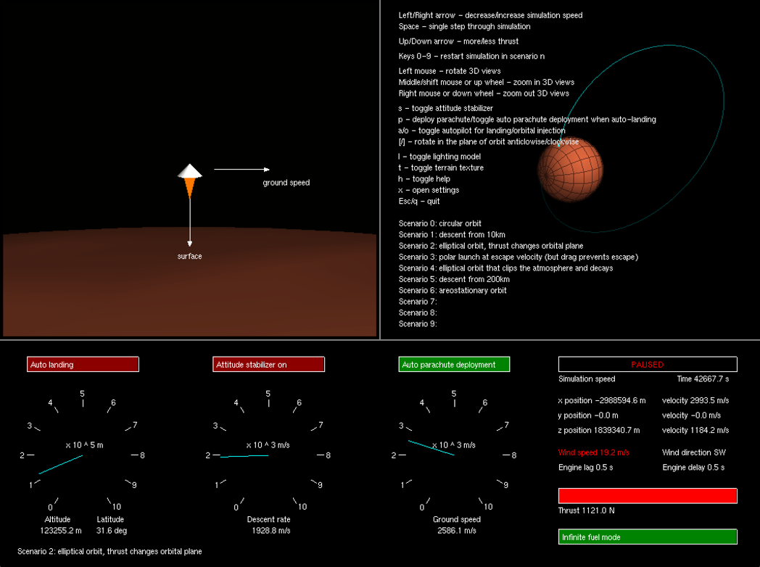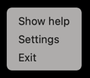

Displays latitude in degrees

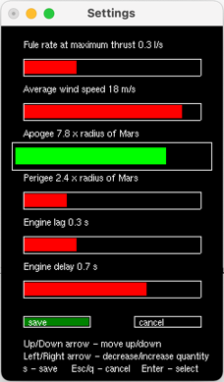

Press **x** to open settings, use arrow keys to change settings, **s** to save and **Esc** or **q** to cancel the changes

Right-click on instrument window for popup menus

Indicates infinite fuel mode when the user sets the fuel rate to zero

Displays engine lag and delay

Displays wind speed and direction, red font color indicates a wind gust

During auto landing press **p** to toggle between auto parachute deployment and engine-only landing

Press **a** for auto landing and **o** for auto orbital injection into desired orbit

Press **[** for anti-clockwise rotation and **]** for clockwise rotation when attitude stabilizer is on

New scenarios



Apogee and Perigee for auto injection orbit

(Set them equal for circular orbit injection)

Minimal fuel usage and minimal descent time achieved by targeting a logarithmic relationship between descending speed and altitude

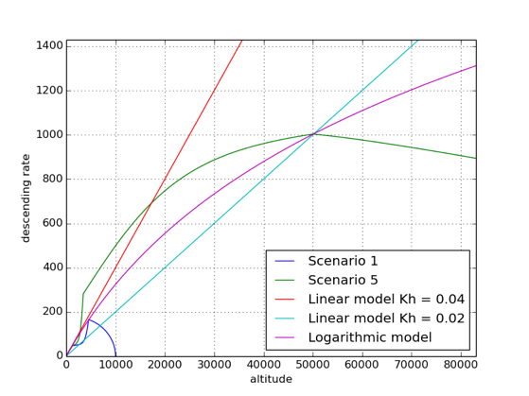

Only for high altitude

Only for low altitude

Positive error points

*The graph shows descending rate over altitude for auto landing using logarithmic model in scenario 1 and 5. Linear model with Kh = 0.04 allows for the fastest landing from low altitudes (scenario 1), however when landing from high altitudes (scenario 5), lander crashes because the point where the error term becomes positive is too late. Linear model with Kh = 0.02 ensures safe landing from high altitudes, however such relationship is unnecessary in low altitudes and increases the descent time. Logarithmic model with a gradient near 0.04 at low altitude allows for both safe landing from high altitude and the fastest descending.*

Enables toggle between parachute landing and engine-only landing when auto landing

Supports setting window that allows user to manually set fuel rate, average wind speed, apogee and perigee for orbital injection, engine lag and engine delay

Supports right-click on instrument window for popup menus